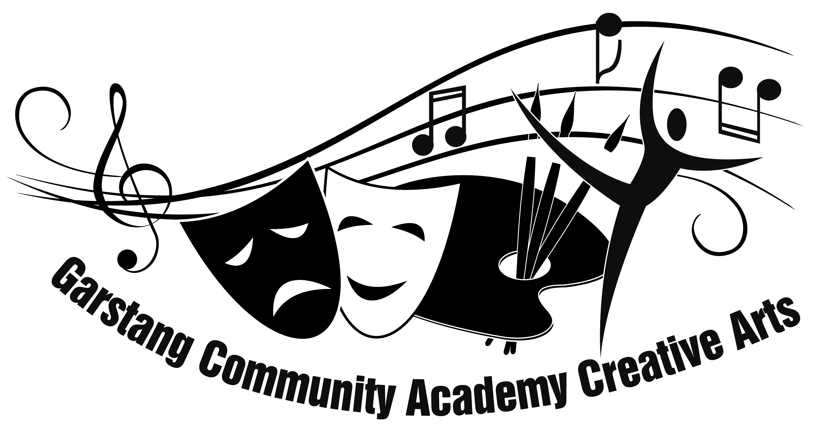

INSTRUMENTAL & VOCAL TUITION
~ Enhancing Your Child’s Education ~

Dear Parents / Carers,

Welcome to Creative Arts at Garstang Community Academy (GCA, we, us, our). As part of our wide ranging and successful programme of enrichment activities, we are also able to offer instrumental and vocal tuition provided by our excellent team of visiting tutors. All tutors are well-qualified, professional musicians with extensive experience of attaining the highest possible standards from our students.

We can offer your child:
- Access to a wide range of ensemble & performance opportunities including international concert tours
- An enhanced profile within the whole school community
- 15, 20 or 30 minute tuition slots operated via a rotating timetable
- Student progress reports at the end of each Autumn and Summer term
- Access to external examinations (attracting UCAS entry points)
- Competitive rates of tuition
- Access to our interest free instrument purchase scheme

‘Involvement in music engages and re-engages pupils, increasing their self-esteem, and maximises their progress in all areas of education’ OFSTED
We believe this to be an excellent opportunity to enable your son / daughter / cared for student to have the best possible start at GCA and to maximise their full potential.

Should you wish for your Son / Daughter / Cared for student to begin tuition in school (initially for the Autumn term only), please fill in and return the attached Instrumental / Vocal Tuition Reply Slip (July 17 edition) (Slip) to Mrs Gregory by [DATE] or by sending an email to hgregory@garstangcommunityacademy.com. Whether you return the Slip or send an email by confirmation you acknowledge that you have read, understood and agree to the terms and conditions set out within the attached Terms for Instrumental / Vocal Tuition (July 17 edition) (Terms). This letter, together with the Terms and the Slip shall form the entire agreement between the parties.

No payment is required at this time: tuition fees are payable, in advance, at the start of each academic term.

Please do not hesitate to contact me directly should you wish to discuss our tuition programme further. For full terms and conditions please refer to the attached Terms.

Yours faithfully,

Mrs H Gregory
Leader of the Creative Arts

Terms for Instrumental / Vocal Tuition (July 17 edition)

1. Payment
- Lessons are charged at a rate of £29.00 per hour. Students receive lessons on a one-to-one basis for either 20 or 30 minutes per week at a cost of £9.67 or £14.50 per lesson respectively and as selected within the Slip.
- Personalised invoices will be distributed to students via their form teacher at the start of each academic term.
- Payment must be made to the relevant tutor and not to GCA. The tutor’s name will be made clear on the invoice. Payment must be made by the 2nd lesson following the date of the respective invoice. If payment is not received by the 2nd lesson, the tutor reserves the right to postpone tuition; however, the full invoice amount will still be sought. In the event that payment is not made within 14 days of GCA notifying you that it is overdue then we may terminate this Contract upon immediate notice.
- All other costs (music books, exam fees etc.) must also be paid for as directed within the relevant invoice. Advice for these will be given as and when the need arises and all costs will be advised in advance of the invoice being raised.
- Any requests for subsidy must be addressed to the Principal of GCA, Mr Ashcroft, and not to the instrumental tutor.

2. Cancellation
- This is a rolling contract and unless you provide us with express notification of your cancellation it shall remain in force indefinitely. All notices of cancellation must be made in writing and posted into the Blue Box in the reception area addressed to Mrs Gregory
- Notices of cancellation must be received at least a half-term in advance (see below):
To cancel tuition with effect from: | Final notice is due:
Autumn Term | Friday preceding May half-term
Spring Term | Friday preceding October half-term
Summer Term | Friday preceding February half-term

3. Attendance / Refunds
- Students will be placed on a weekly ‘rotating’ timetable where feasible. Timetables are displayed on a notice board in the Performing Arts Studio corridor. If in doubt, students should speak to Mrs Gregory in the first instance. Students are to take responsibility for attending their lessons on time, together with all necessary equipment. No refund will be issued for failure to attend or lateness to a lesson nor where the student fails to bring any or all of the necessary equipment to the lesson.
- In most cases, tuition takes place during the course of the normal school day and students will need to excuse themselves from their scheduled lesson: this is standard practice agreed by the Senior Leadership Team. All teaching staff in school have been forwarded a copy of the tuition timetables in advance. For the avoidance of doubt, it is the responsibility of the student to inform the relevant teacher that they will require to be excused and you shall still be liable to pay for a lesson where the student fails to excuse themselves.
- Some lessons do take place at lunchtimes and break times; however, priority for these is given to students with additional needs or those in Years 10 and 11. Please make a specific request if you consider this to be required.
- If students are unable to attend their lesson due to an academy trip, they must tell their tutor at least ONE WEEK in advance, otherwise the lesson will be forfeited with no refund given.
- Please note, that where other activities are taking place in school i.e. award’s assemblies, internal exams, sport’s day etc. it is still the student’s responsibility to attend their lesson on time. Any requests to swop lesson times on an ad hoc basis must be made directly to Mrs Gregory who will endeavour to honour all requests where feasible.
- If students are not at the academy due to illness or other personal circumstances and music tuition is missed as a result, no refund will usually be given as the instrumental teacher will not be able to make up the lost time; however, where possible, tutors will endeavour to make up the missed lesson (when another student is absent, for example). We reserve the right to issue a refund only in special circumstances.
- If a tutor is absent for any reason, the lesson will at our absolute discretion either be made up at another time, refunded or deducted from the next term’s bill.

4. Practice
- All students are expected to do an appropriate amount of practice at home; attending lessons alone may result in insufficient progress being made. GCA does not make any guarantees that a student will progress in their respective discipline. Initially, an average of 15 minutes practice per day will be sufficient, but as students become more proficient, this should be increased. Drum and piano students will need to access an instrument on which to practise. Limited facilities for both these instruments are available at GCA; however, practice rooms can be reserved through Mrs Gregory. Initially, a keyboard with full size keys will be acceptable for piano students.

5. Instruments
- All students (apart from piano and drums) are expected to acquire their own instrument prior to their first lesson. If buying a new instrument is not an option, you may consider purchasing a second-hand instrument or hiring an instrument, particularly if you are not sure if your son / daughter / cared for student is going to commit to their lessons long-term. A VAT free ‘assisted instrument purchase scheme’ is now in operation: please see the school website (parent portal) for further details. This is run in conjunction with ‘The Music Cellar’, 12 Fox Street, Preston, PR1 2AB, 01772 251407, www.themusiccellar.co.uk

6. Communication
- Students are expected to provide a notebook in which tutors can comment on areas for practice and to communicate with parents. If there is a problem or query regarding your son / daughter’s tuition, you can contact the appropriate tutor in writing in the first instance; subsequently, you may wish to contact Mrs Gregory. It is anticipated that a short written report will be issued at the end of each Autumn and Summer term respectively by tutors in order to keep parents / carers up-to-date with progress.

7. General
- The contract between you and GCA (Contract) is comprised of the Terms, the Slip and the covering letter and for the avoidance of doubt nothing which is not expressly set out herein shall form part of the Contract. Any words used throughout the aforementioned documents shall take the meaning given to them within this Contract. The Contract is governed by the law of England and subject to the exclusive jurisdiction of England.
- You agree and acknowledge that you take full responsibility for the actions and behaviour of those children under your responsibility and who receive lessons and shall fully reimburse the school on a pound for pound basis for any losses or liabilities which it suffers as a result of the actions and behavior of those children. All children receiving lessons should at all times meet the same standards of conduct as if they were in attendance at the school itself and will be judged accordingly.
- If there are any issues with the lessons or the tutors then you must notify us in writing immediately.
- Any breach of the terms of this Contract will entitle GCA to terminate it upon immediate notice and without liability to you for any sums paid in advance.

